Always show all work for full credit.
- Determine the minimal expression minimal (the Karnaugh map sense) for Y in:
A | B | C | Y
0 | 0 | 0 | 1
0 | 0 | 1 | 1
0 | 1 | 0 | 0
0 | 1 | 1 | 1
1 | 0 | 0 | 0
1 | 0 | 1 | 0
1 | 1 | 0 | 0
1 | 1 | 1 | 1

- Determine the minimal expression minimal (the Karnaugh map sense) for Y in:

A | B | C | D | Y
0 | 0 | 0 | 0 | 1
0 | 0 | 0 | 1 | 1
0 | 0 | 1 | 0 | 0
0 | 0 | 1 | 1 | 0
0 | 1 | 0 | 0 | 1
0 | 1 | 0 | 1 | 0
0 | 1 | 1 | 0 | 0
0 | 1 | 1 | 1 | 1
1 | 0 | 0 | 0 | 0
1 | 0 | 0 | 1 | 0
1 | 0 | 1 | 0 | 1
1 | 0 | 1 | 1 | 0
1 | 1 | 0 | 0 | 1
1 | 1 | 0 | 1 | 1
1 | 1 | 1 | 0 | 0
1 | 1 | 1 | 1 | 1

- Determine the minimal expression minimal (the Karnaugh map sense) for Y in:
A | B | C | Y
0 | 0 | 0 | 0
0 | 0 | 1 | 1
0 | 1 | 0 | 0
0 | 1 | 1 | 1
1 | 0 | 0 | 1
1 | 0 | 1 | 1
1 | 1 | 0 | 0
1 | 1 | 1 | 0

- Determine the minimal expression minimal (the Karnaugh map sense) for Y in:
A | B | C | D | Y
0 | 0 | 0 | 0 | 1
0 | 0 | 0 | 1 | 1
0 | 0 | 1 | 0 | 1
0 | 0 | 1 | 1 | 1
0 | 1 | 0 | 0 | 0
0 | 1 | 0 | 1 | 0
0 | 1 | 1 | 0 | 0
0 | 1 | 1 | 1 | 0
1 | 0 | 0 | 0 | 1
1 | 0 | 0 | 1 | 0
1 | 0 | 1 | 0 | 0
1 | 0 | 1 | 1 | 0
1 | 1 | 0 | 0 | 1
1 | 1 | 0 | 1 | 0
1 | 1 | 1 | 0 | 0
1 | 1 | 1 | 1 | 0

- Problems 1-4 used the same functions as problems 2-5 on Homework 2A. In what way are the equations optimal or minimal compared to the equations in Homework 2A?
- Determine a minimal (the Karnaugh map sense) form of:
$$Y=A\overline{C}+A\overline{B}\overline{C}+B\overline{C}$$

- Determine a minimal (the Karnaugh map sense) form of:
$$Y=\overline{A+\overline{A}B+\overline{A}\overline{B}}+\overline{A+\overline{B}}$$

- Give the minimized (the Karnaugh Map sense) Boolean equation for the function performed by the multiplexors below. Note that A is connected to the inputs to the leftmost multiplexor. The “T” shape on the right multiplexor’s input indicates a voltage source (that is, a logic 1) and the triangle on the left multiplexor’s input represents a ground (that is, a logic 0):
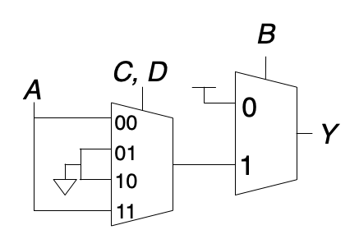

9. Use an 8-to-1 Multiplexor to implement the same function from the previous problem. Use A, B, and C as the “Selectors” for the multiplexor, with C being the least-significant bit (rightmost bits / 1’s place).

10. Assuming the propagation delays are:
Gate | $t_{pd}$ (ps)
NOT | 15
2-input NAND | 23
3-input NAND | 30
2-input NOR | 30
3-input NOR | 45
2-input AND | 30
3-input AND | 40
2-input OR | 40
3-input OR | 55
2-input XOR | 60

Determine the propagation delay of:
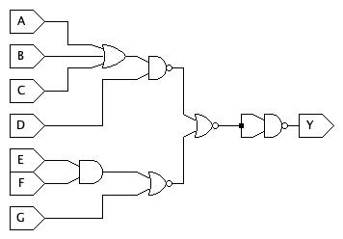

11. Problem 11 is described on the assignment page.
  - Complete the full truth table for the multiplexor with enable (described on assignment page):

  - Find the full, canonical sum-of-products equation for it.
  - (JLS Submission)
11.4 What is the Propagation delay in JLS (using default delays)? (You can right-click on gates and select “Change Timing” to examine their default timing values, but do not change them).
  - Give the minimized (the Karnaugh Map sense) Boolean equation for the function.
  - (JLS Submission)
  - What is the Propagation delay in JLS (using default delays) of the minimized circuit?
  - Compare and contrast the minimal (K-Map) version with the full Sum-of-Products version.

